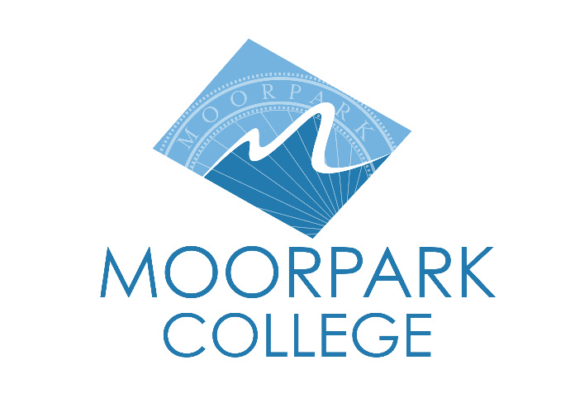

FOR IMMEDIATE RELEASE

Moorpark College Theatre Arts Announces Auditions For Thornton Wilder’s Classic “Our Town”
Auditions for the bilingual production are Aug. 10-12

MOORPARK, Calif. (July 29, 2026) — The Moorpark College Theatre Arts Department is pleased to announce auditions for its upcoming Fall 2026 production of Thornton Wilder’s ”Our Town.” This production revisits the first play performed in the Moorpark College Performing Arts Center as a part of the college’s 60th anniversary celebration.
The iconic, Pulitzer Prize-winning play is reimagined for the 21st century in an English/Spanish translation featuring translated passages by Michel Hausmann. With new layers of language and culture, ”Our Town” expands to encompass everyone in a quintessentially American — and human — story. Narrated by a stage manager and performed with minimal props and sets, ”Our Town” depicts the small town of Grover’s Corners, New Hampshire, through three acts: “Daily Life,” “Love and Marriage” and “Death and Eternity.”
“We are very excited to bring this classic play back to our main stage,” said John Loprieno, Director and Theatre Arts faculty member. “In keeping with the themes of honoring lived experiences and cherished memories explored in Thornton Wilder’s classic play, we thought that ‘Our Town’ was the perfect play to open our 2026-2027 Moorpark College Performing Arts Season. We’re looking forward to launching the Moorpark College 60th Anniversary celebration across campus!”
“Our Town” will run October 8-18 in the Main Stage Theater at Moorpark College’s Performing Arts Center. Evening performances are Thursday through Saturday at 8 p.m., with Sunday matinees at 2 p.m. Tickets go on sale September 1 and may be purchased through the Moorpark College Performing Arts Center Box Office at (805) 378-1485 or online at www.moorparkcollege.edu/pac. The department will also offer free weekday high school matinees at 10 a.m. on October 13 and 14.
Preliminary auditions will be held in the Studio Theatre, Room PA-100, in the Performing Arts Center on Monday, August 10, 3:30-6 p.m. and Tuesday, August 11, 6-10 p.m. Callbacks will be held Wednesday, August 12, 6-10 p.m. Anyone interested in auditioning should be prepared to read from provided audition sides available on the Moorpark College Theatre Arts auditions and rehearsals webpage.
Auditions are open to students and community members. Those cast must enroll in the 3-unit Theatre Production: Performance class. For additional information regarding ”Our Town” or the Moorpark College Theatre Arts Department, please contact Director John Loprieno at (805) 378-1469 or jloprieno@vcccd.edu.

About Moorpark College
Moorpark College is one of three colleges in the Ventura County Community College District and annually serves more than 18,000 students. Founded in 1967, Moorpark College is fully accredited and has the highest six-year completion rate within the California Community College System. An Aspen Institute Top 10 Finalist for 2023 and 2025, Moorpark College has also been named a 2020 Champion of Higher Education by The Campaign for College Opportunity for the Associate Degree for Transfer Pathway. It is also a designated Hispanic-Serving Institution. The college’s signature career/technical programs include nursing, radiologic technology, biotechnology, and cybersecurity. The college’s America’s Teaching Zoo is the only associate degree animal care and training program in the country. To learn more, visit MoorparkCollege.edu or follow @MoorparkCollege on social media.

Media Contact:
communications@vcccd.edu
805-652-5502

